**Software Project Management Plan**

**for**

***Go Paperless***

***Anwer Amin***

***10th April 2015***

|  |  |  |
| --- | --- | --- |
| **Version 1.0** |  |  |

|  |  |  |
| --- | --- | --- |
|  |  |  |
|  |  |  |  |

Contents

**1.** **Introduction** 2

**1.1** **Project summery** 2

**1.1.2** **Assumptions and Constraints** 4

**1.1** **Evolution of the SPMP** 7

**2.** **References** 8

**2.1** **Software Requirements Specification (SRS)** 8

**2.2** **Software Design Specification (SDS)** 8

**2.3** **Software Test (STP)** 8

**2.4** **IEEE Standard 1058-1998** 8

**3.** **Definitions** 8

**4.** **Project Organization** 9

**4.1** **External interfaces** 9

**4.2** **Internal interfaces** 10

**4.3** **Roles and responsibilities** 11

**5.** **Managerial Process Plan** 12

**5.1** **Start-UP Plan** 12

**5.2** **Work Plan** 13

**5.3** **Control Plan** 15

**5.4** **Risk Management** 16

**5.5** **Project Closeout plan** 17

**6.** **Managerial Process Plan** 17

**6.1** **Project process model** 17

**6.2** **Methods, tools and techniques** 17

**6.3** **Infrastructure plan** 18

# **Introduction**

The Software Project Management Plan (SPMP) for the GoPaperless project defines the approach to project management; that being the project management goals of the project and includes a description of the deliverables and deadlines.

In today’s world when computers and digital data has become the main force driving progress in the corporate world. In the 80s when computer were just starting to make their way into corporate offices it was thought that an ideal office environment where all information is shared and stored digitally is just around the corner. Ironically the truth is that many offices around the world and more importantly most in Pakistan still use paper has the main medium for information sharing and storage. It is estimated that a company spends up to % 15 of its total revenue in the production of paper documents, its management and storage.

The Go Paperless project is designed to remedy this problem by building a web based software that allows for easy digitization of the office environment allowing for greatly reduced paper usage and in turn reducing the cost relating to paper as well as improving information sharing and storage. This reduced use of paper not only aids the company in monetary terms but also reduces the environmental impact it has.

Additionally, the team has a goal to fulfill the requirements of the Software Engineering 2 course.

The Go Paperless team consists of: Anwer Amin, Imad Ali and Tanzeel Ur Rehman.

## **Project summery**

This section of the Software Project Management Plan (SPMP) gives an overview of the purpose, scope and objectives of the project. It also contains sections regarding the assumptions and constraints, the project deliverables, the summary of the schedule, and the plan for change in the SPMP.

* + 1. **Purpose, scope and objective**

The purpose of this document is to serve as a guide for development of the project and making sure that all requirements are met and the produced system functions according to the requirements. The SPMP will detail the major activities, resources, schedules and milestones for developing the Go Paperless software.

The project is to develop a web based system that allows its users to create digital forms which can be used by the employees of a company to record, retrieve and share data without the need to print it. The system is designed to achieve easy digitization of the office environment without extensive knowledge of programming or database management.

The project is divided into two major portions:

* The website: which acts as the user portal with a responsive dashboard containing all the options and feature available to a user.
* Formbuilder: this allows the user to dynamically create and publish forms without the need to program it into the system, all programming and database operations will be done by the system automatically.

Any company that wants to shift to your system from a paper-based one will simply need to sign up at the website selecting the appropriate package for their organization’s size and data requirements. Using this organization account one or more Administrator accounts can be created. The user of these accounts will be responsible for the creation of the forms as well as creation of employee accounts. Employee will be able to view data and use forms that have been assigned to them.

The objectives of the project are as follows:

* Complete the project by the project due date
* Complete the project should be completely functional.
* All the deliverables identified in 1.1.3 are delivered by the project due date.
* All the requirements in the SRS are satisfied within the scope of the project.
* The documentation provided is complete and up to date.
* The project satisfies the requirements of the Software Engineering 2 course.

### **Assumptions and Constraints**

There are several assumptions and constraints that are of importance for the project and its team members:

#### **Assumptions**

* The development team has knowledge of common software engineering practices.
* The development team is competent in the technologies used in the project.
* The development team has knowledge in: HTML, CSS, JavaScript, JSP and MySQL 5.
* The development team is capable of producing the required documentation.
* The available resources are enough to complete the project on time.
* The project deadline is reasonable for a project of this scope.
* The project team have proper medium of communication.
* The developed software will be a complete and independent system.
* The software product will be supported on all modern browsers.
* The software product is a web based and will require constant internet access.

#### **Constraints**

* The project team most provide a weekly record of their meeting, Minutes of meeting.
* Due to the nature of its users who might not be technologically savvy the software must be simple to understand and use requiring minimal skill for the employee role.
* The software must function on all popular web browsers.
* The team member time on the project will be limited due to others academic concerns.
* No additional human resources will be available.
* No financial resources are available for the project.
  + 1. **Project deliverables**

The Go Paperless team will produce a fully functional system as well as a appropriate documentation.

* The project deliverable will delivered in the first week of May.
* The documentation will be provided in the form of a hard copy.
* The software will be available for download from an online repository.
* The database will be provided in the form of an executable script.

#### **Software deliverables**

The Go Paperless team will provide a functional software by the end of the project which will satisfy all requirements mentioned in the SRS.

It will also provide any additional libraries or resources that maybe required to set up the project.

#### **Document deliverables**

A number of documents will be delivered by the Go Paperless team during the course of the project.

* Work Breakdown Structure (WBS)
* Gant Chart
* Presentation Slides.
* Weekly Minutes of Meeting (MOM)
* Software Requirements Specification (SRS)
* Software Design Specification (SDS)
* Software Project Management Plan (SPMP)
* Software Test Plan (STP)
  + 1. **Schedule and Budget Summary**

The project has the following high-level schedule:

* Project Budget: undefined, all software production will done with tools and resources already available.
* Software products ready for operation: first week of May.

The Schedule of the project is tracked using the Gant chart and WBS.

|  |  |  |
| --- | --- | --- |
| **Project milestone** | **Project artifact** | **Due date** |
| Project start |  | 12/2/2015 |
| SRS | Document | 16/2/2015 |
| Phase 1 Completion | Design Documentation | 15/3/2015 |
| First presentation | Use cases, ERD , Project Scope | 18/3/2015 |
| SPMP | Document | 10/4/2015 |
| Phase 2 completion | Software development | 26/4/2015 |
| Software Testing | Software Design Specification | 30/5/2015 |
| Project delivery | Software, All Documentation | 7/5/2015 |

## **Evolution of the SPMP**

The SPMP for the Go Paperless project will be under version control so any changes will be made to the plan itself. The updated document will be made available to all project members Also, the most recent version of the document will be posted available on the GitHub repository.

The project members will be notified of the change via email as well as automated notification from GitHub.

# **References**

## **Software Requirements Specification (SRS)**

|  |  |
| --- | --- |
| Version | 1.0 |
| Date | 16/2/2015 |
| Author | Anwer Amin |
| Access information | GitHub Reposatory //Master/documentation/SRS.doc |
| Publisher | Anwer Amin |

## **Software Design Specification (SDS)**

|  |  |
| --- | --- |
| Version | 1.0 |
| Date | 18/3/2015 |
| Author | Tanzeel Ur Rehman, Anwer Amin |
| Access information | GitHub Reposatory //Master/documentation/SDS.doc |
| Publisher | Anwer Amin |

## **Software Test (STP)**

|  |  |
| --- | --- |
| Version | 1.0 |
| Date | 16/2/2015 |
| Author | Tanzeel Ur Rehman |
| Access information | GitHub Reposatory //Master/documentation/STP.doc |
| Publisher | Anwer Amin |

## **IEEE Standard 1058-1998**

|  |  |
| --- | --- |
| Access information | http://shop.ieee.org/store/product.asp?prodno=SS94976 |

# **Definitions**

|  |  |
| --- | --- |
| **TERMS** | **DEFINATIONS** |
| SLOC | Source Lines of Code |
| WBS | Work Breakdown Structure |
| SRS | Software Requirements Specification |
| IEEE 1058-  1998 | the IEEE standard for Software Project Management Plans on which  this plan is based |
| work package | a specification of work that must be accomplished to complete a work  task |
| project  deliverable | a work product to be delivered to the acquirer |

# **Project Organization**

The SPMP will identify the organizational entities external to the project and their interaction with the project team, as well as internal project structure and roles and responsibilities for the project.

Section 4.1 describes the external interfaces to the Go Paperless project team, section 4.2 describes the internal structure of the team, while section 4.3 describes the roles performed by the team members

## **External interfaces**

The communication between with external sources is limited for the project as it is being developed a general product and not one tailored of a specific client.

For the SE2 course the communication with the Instructor is done via email, face to face conversations as well as documentation showing the progress of the team in the project.

Any communication with external sources is done via email.

## **Internal interfaces**

Team Leader

Technical Writer

Front-End Developer

Back-End Developer

Figure 1 Internal team structure

The internal structure of the team seen here is a hierarchical model. The team leader is responsible for the planning of work and assigning the different roles to the resources. All team members have their own area of responsibility assigned to them by the team leader in accordance to their individual skills.

Some overlap exists between the roles due to the limited number of available human resources. All Team members are involved in problem solving and are encouraged to make their opinion known. Decision making power is delegated to the members when working in order to insure that rapid development is possible.

In a case when the decision is on reachable for team mates the team leader will intervene. The team will engage in regular weekly meetings. Additionally team members will communicate by e-mail on as needed basis. Personal communication between team members is strongly encouraged.

## **Roles and responsibilities**

Following are the roles assigned to team members*:*

|  |  |
| --- | --- |
| **Team members** | **List of Responsibilities** |
| Anwer Amin | * Team leader * Lead the team in producing the development strategy * Lead the development of Go Paperless SRS * Lead the team in producing the high-level design * Lead the team in producing the design specification * Lead the team in developing the build, integration and system testing. * Lead the team in producing the balanced team plan * Creates and maintains Go Paperless SPMP * Creates and maintains Go Paperless Gant Chart * Maintain the project notebook * Maintain the team’s issue and risk tracking system * Leads the team in the development of the database * Member for the back end coding team |
| Imad Ali | * Team Developer * Leads the team in the development of the System production * Leads the team in solving problems with the system * Responsible for the development of the test bed Formbuilder. * Responsible for the development of the website design. * Responsible for FormBuilder implementation * Responsible for the Notification system. * Maintains the project repository * Communicates problems with external sources. |
| Tanzeel Ur Rehman | * Technical Writer * Lead the team in determining its support needs and in obtaining the needed tools and facilities. * Maintain the team’s issue. * Lead the team in producing the product’s user documentation. * Alerts the team to quality problems |

# **Managerial Process Plan**

The SPMP will specify the project management processes for the project and will include: the project startup plan, risk management plan, project work plan, project control plan and project closeout plan.

In order to be successful the team must deliver a software product that will satisfy requirements outlined in the Go Paperless SRS.

## **Start-UP Plan**

The SPMP outlines the resources and materials needed to start the project and will include: estimation plan, staffing plan, resource acquisition plan and training plan.

|  |  |  |  |
| --- | --- | --- | --- |
| **Project Dimension** | **Fixed** | **Constrained** | **Flexible** |
| Cost | X |  |  |
| Schedule | X |  |  |
| Scope (functionality) |  |  | X |

* + 1. **Resource Acquisition Plan**

The expectation is that all of the resources will be available from the beginning of the project until the project completion and they should not change for the duration of the project.

We will be considering

The resources needed for completion of the project can be separated into the following categories:

* Hardware resources.
* Software resources.
  + - 1. **Hardware resources**

All members of the teams should have computers capable of running windows 7 operating system as well as modern web browsers. Members responsible for development should have access to mobile and tablet devices to insure proper design across the board as the project is a web site it is essential that the system response is good on devices with different screen sizes.

* + - 1. **Software resources**

Team members responsible for development must have an IDE with support for STRUTS2 , Java and JSP, as well as a text editor for html and CSS  
Recommended software:

* Photoshop (graphic design)
* Eclipse IDE
* Sublime
* Struts 2 JREs

Team members responsible for producing the documentation should have access to MS Project, MS Office and Edraw Max.

## **Work Plan**

* + 1. **Work Activities**

Figure 2 Work Breakdown Structure

* + 1. **Schedule and resource allocation**

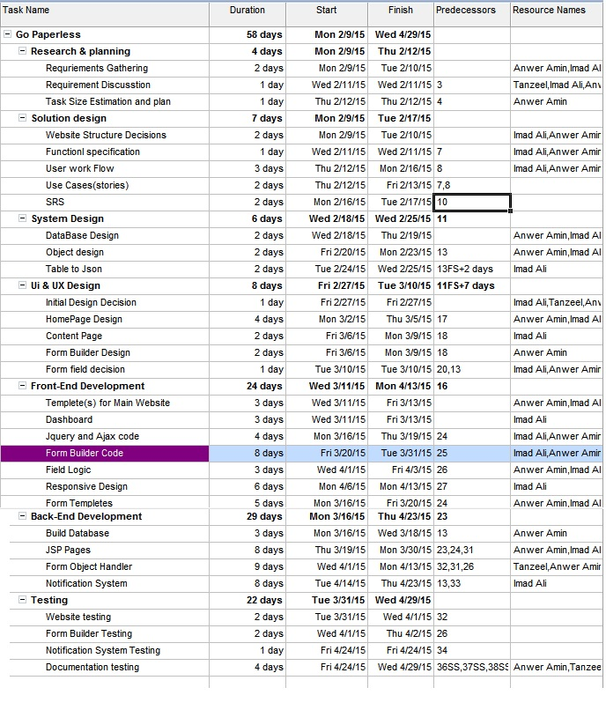

Figure 3 Gant Chart

## **Control Plan**

* + 1. **Requirements Control plan**

This Plan defines how requirements will be recorded; how requirements will be modified; and how requirements will be reconciled for final completion of the product.

The Requirements are tracked using Tables from the schedule. The SRS is used to track all requirements by the team lead.

We will focus on change control any time a change is made it will be recorded and documented so that it can be conveyed to all members of the team. Especially the test and development members as they will be effected the most.

* + 1. **Schedule Control plan**

The Schedule for the Go Paperless project is maintained in a gant chart which is available to all members of the team, the project leader monitors the schedule subdividing the tasks into phases so that deliverables are produces on time. The schedule is monitored continuously and any slippage is notified to the leader immediately so that it can be corrected.

* + 1. **Reporting Plan**

To insure proper communication of facts between the team members and other stakeholders there is reporting structure in place.

* + - 1. **Internal reporting plan**
         1. **Weekly Project Group Meetings**

The entire group meets every week at time all members are available to address issues that may have arisen or to discuss how work will be done in the coming week, members are encourages to bring forth any problems that may have arisen.

* + - * 1. **Code meetings**

Members of the coding team are in constant communication during the coding phase. This is often done in person, team members sit at the same location to discuss issues or ideas.

In any case that the team members cannot be located on in the same place, a skype call is made and left open so that an problems can solved without any waiting.

* + - 1. **External reporting plan**

Weekly Minutes of meetings are produced to keep all communication between members during the weekly meetings is recorded.

## **Risk Management**

To manage the risk associated we have created a spate document that will note and risk when identified and will record its intensity

* H for High risk that need to fix immediately large time slips, catastrophic design issues.
* M will denote smaller issues that can will not affect the project greatly if fixed in time.
* L will denote issues that can be temporary ignored.
* O will denote issues with indeterminate intensity but must be monitored carefully.

The Risk management is done by the team leader but also on a smaller scale my members for their own areas.

## **Project Closeout plan**

The project will end with the delivery of all mentioned deliverables.

* Working software.
* Full documentation.

# **Managerial Process Plan**

The SPMP will specify the development process model, technical models, tools and techniques that will be used to develop the work products and project infrastructure.

## **Project process model**

|  |  |  |
| --- | --- | --- |
| **Phase** | **Start and finish date** | **Phase goals** |
| Project  Start | 12/02/2015 – 20/2/2015 | - Strategy planning  - Learning about paperless environment theory  - Developing the SRS |
| Requirements | 21/02/2015-28/2/2015 | - Become familiar with requirements and assigning tasks  - Create database design |
| Design phase | 28/02/2015 – March 2015 | - Design phase |
| Development | March 2015 – April 2015 | - Development/Coding phase  - Coding |
| Finishing | May 2015 | - Testing Phase |

## **Methods, tools and techniques**

We will be using various web technologies to develop this project.

* Photoshop (graphic design)
* Eclipse IDE
* Sublime
* MySQL JRE

## **Infrastructure plan**

As the project is a website it will require a webserver to host the website as well as the database. Client Databases will be available for as scripts.